# The Format Function

## Background

The formatting function make the right format for an xml file by keeping the right indentation for each tag level. It also depends on the GUI window to set the indentation and the new lines.

## Parameters and Return

* **The function takes as input:**
* xml string
* The width of the characters of the GUI window
* **The function returns**: formatted xml string

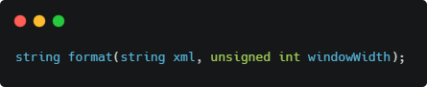

## Implementation details

* First the function calls the minify function to remove any wrong formatting.
* Takes the xml version tag if any.
* Iterate over the minified xml and copy the data into the output string.
* 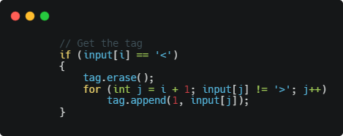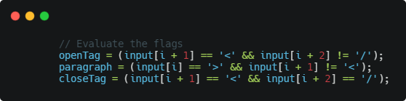Update the tag with the current one and update the flags according to the coming tag or paragraph
* It updates generally the level of indentation in case of open or close tags.
* 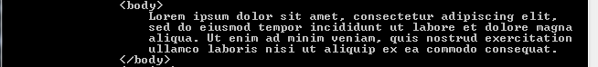For long paragraph it split it into lines match the width of the GUI window.
* If a tag has not any children and can fit the width of the GUI window, it will put this tag with its open, close and text in one line with the last indentation

## An image of output formatted xml on the Consol window

## The data structure used in this function

**String:** which uses vector contains a **dynamic array** object.

## The complexity of the function

The time complexity: **O(n),** n is the number of characters in the xml input string

The space complexity: **O(n),** n is the number of characters in the xml input string